AUTO COMPLETE DOCUMENTATION

# INSTALLATION INSTRUCTIONS

## # INSTALLATION APPLICATION

npm install

## # RUN APPLICATION

npm start

## # RUN TESTS

npm test

press `a` to run all tests

after running `npm test`, make sure to press `a`, as for the first time tests are not properly running.

# UI DESIGN

Following are UI screenshots.

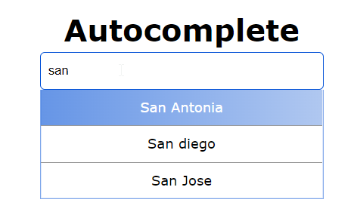

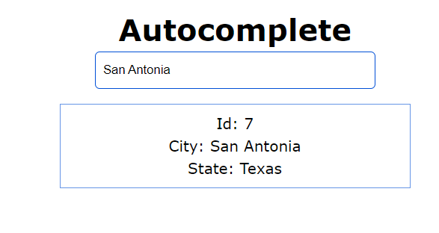

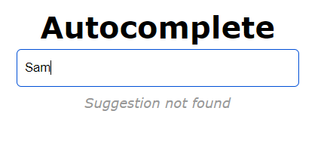

# UNIT TESTING

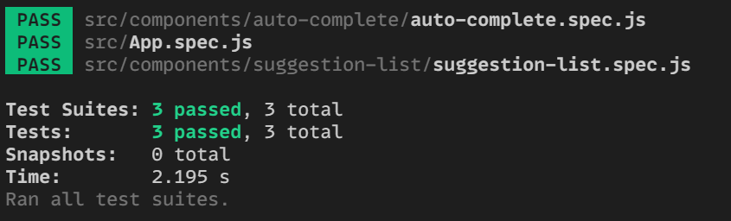

All test cases are covered and passed.

# SCOPE FOR IMPROVEMENTS

1. A wide search box can be built.
2. Data can be fetched from API.